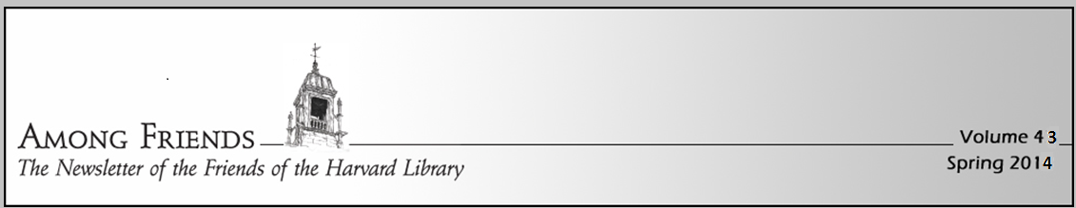
Dear Friends:
I hope this finds you and your loved ones well in these trying times. We are putting out a shorter newsletter this year given our tightened budget. As you may have noticed, we could not run our annual book sale this year. The book sale is how we raise more than 50% of our funds. The other large portion of our funding comes from our annual memberships. Enclosed is our annual membership renewal envelope – please consider joining the Friends this year (or renewing your membership)!

The money we raise goes directly back to the library to pay expenses beyond what our taxes cover. For example, even during this difficult summer, more than 200 children participated in the Summer Reading Program sponsored by the Friends.

Thanks to the creative staff at HPL, many services are still available including curbside pickup of materials. The extensive Virtual Library is always available. In addition, you can email the name of one of your favorite books or authors, and staff will turn it into THREE new book suggestions! Adult & Teens:reference@harvardpubliclibrary.org
Children's books: childrensroom@harvardpubliclibrary.org So cool!

Many remote programs have continued through the spring and summer including favorites such as Dinoman, Rainforest Reptiles and the Pumpernickle Puppets (all sponsored by FOHPL). Now that museums are reopening, we will be renewing our museum passes. We hope to bring concerts back to Volunteers Hall in 2021 or when it is safe to do so again.

I know everyone has a lot of competing budget priorities right now, but I do hope you will consider helping the Friends stay in our active partnership with the Library. I hope you will consider a tax-deductible donation to the Friends.

Thank you and stay safe,
Chris Frechette, FOHPL President
Congratulations to Vivien Jamba for winning the Dr. Jeffrey Harris Scholarship. The Friends sponsor this scholarship to honor Dr. Harris who spent a lifetime of commitment to our community. The award is given to a senior who exemplifies that spirit.

From the Children’s Room – Abby Kingsbury
Volume 40
Summer 2020
Children’s services at the HPL have entered the virtual world, including live Zoom storytimes and book groups, virtual performances sponsored by the Friends of the HPL, and a YouTube channel with videos divided into multiple playlists, including a playlist that features New Books. The link for the HPL Children’s Room channel is on the Children’s page of the Harvard Public Library website (https://www.harvardpubliclibrary.org/children).

Our live Zoom storytimes continue to be a wonderful way to see all of our storytime friends and connect virtually; virtual storytimes for three different age groups take place four times a week. Book groups for 3rd, 4th, 5th, and 6th graders have continued on Zoom, too, and each book group will meet once a month through the school year. If you would like to be added to the Zoom email lists for storytimes, or if you would like to join a book group, send an email to: childrensroom@harvardpubliclibrary.org .

And, thanks to the support of the Friends, we had an amazingly successful summer reading program! Summer reading participants surpassed last year’s reading total by reading a total of 442,226 minutes. 125 participants earned a Friends-sponsored prize bag; 111 participants read for 20 hours and earned a Friends-sponsored lawn pinwheel; and 82 participants earned a bookplate by reading for at least 30 hours. Congratulations to all who participated in the summer reading program!
Thank you to all our generous volunteers and donors who make the Friends of the Library so successful. Stay safe! We look forward to seeing you in better times.

Museum Passes at the Library thanks to your donations and book sale proceeds:
Here are just some of the museums for which we have passes. Please be sure to check with the museum ahead of time to confirm visit rules. Call the library to see if the passes are available. DeCordova ~ Discovery Museum ~ Fruitlands ~ Garden in the Woods ~ Institute of Contemporary Art ~ Isabella Stewart Gardner ~ John F. Kennedy Museum ~ Mass Audubon ~ Museum of Fine Arts ~ Peabody Essex

