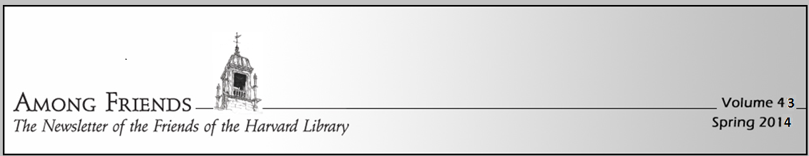
Dear Friends:
I hope this finds you and your loved ones well as spring arrives. We are happy to announce that our Annual Book Sale is coming May 9-11! Please see below for details.
In addition to the proceeds from the book sale, the other large portion of our funding comes from our annual memberships. Enclosed is our annual membership renewal envelope – please consider joining to help us maintain the important programming the Friends support. You can join by donating using PayPal: https://www.harvardpubliclibrary.org/about/friends-library.

The money we raise goes directly back to the library to pay expenses beyond what our taxes cover. For examples, see the reports from the Children’s Room and Teen Programs. We also provide museum passes, a scholarship award and concert programming.

Thank you and I hope to see you in May at the book sale,
Congratulations to Adaline Boissy for winning the 2023 Dr. Harris Scholarship. The award is given to those who exemplify Dr. Jeff Harris’ spirit of community service.

Updates from the Children’s Room – Abby Kingsbury
This has been a busy year for programs in the children’s room! From monthly Family Movie Nights in Volunteers Hall to bi-monthly Paws and Read sessions with the awesome therapy dogs Rhia and Chase and everything in between – including the annual LEGO Expo, the Stuffed Animal Sleepover, the Book Buddies program, and storytimes for all ages, book groups, and the Write Stuff writing group – there is always something going on in the children’s department!

Volume 43
Spring 2024

Thanks to the support of the Friends of the HPL, we
Had an amazing summer reading program in 2023 with
lots of great programs, including the Ice Cream Social, comic mime Robert Rivest, Hula Hooping with Wildkat Hoops, Rainforest Reptiles, and the Pumpernickel Puppets.

Since September, we have hosted many awesome early release/half day programs that were supported by the Friends, including a preschool music series with Hugh Hanley, the AbraKidabra Magic Show, Playful Engineers Chain Reactions Build-Along, Yo-Yos Music Camp, More with Ooch, Dinosaurs with the Dinoman, a Magic Show with Ed Pop, Animals in Spring and Mike the Bubble Man.

Upcoming events: Origami with Michael LaFosse (April), and Flying High Dogs (May). We’re excited to announce that the upcoming Summer Reading program will once again kick off with the Ice Cream Social, with ice cream, toppings, outdoor games, and a live band. Other scheduled performers throughout the year will include a return visit from Playful Engineers, Ed the Wizard, storytelling with Davis Bates, the Toe Jam Puppet Band, and World of Owls with Wingmasters.

All of these great programs are sponsored by the Friends, as are the summer reading prizes! Stay tuned for details on the summer reading calendar, which will be unveiled when the children’s librarian visits HES in June!

Once a month we send out the Children’s Room Newsletter with information about upcoming programs. Send an email to the children’s room to be added to the email list: childrensroom@harvardpubliclibrary.org.

We hope to see you soon!

Teen Updates from Jill Hayes
There’s a lot going on for teens in grades 6 & up at the Harvard Public Library!
Museum Passes
With your support we sponsor more than 20 museum passes. Here is just a sample.
New this year: Zoo New England, Mass Audubon & House of Seven Gables
~
American Heritage Museum (co-sponsored with the Harvard Women’s Club) ~ Boston Children’s Museum ~ Boston Harbor Islands Ferry ~ Butterfly Place ~ Discovery Museum ~ Ecotarium ~ Gardner Museum ~ Historic New England ~ICA ~ JFK Museum ~ MFA ~ MassParks ~ Museum of Science ~ NE Aquarium ~ Peabody Essex Museum ~ Tower Hill Garden ~Worcester Art Museum ~ USS Constitution Museum & many more!
Students are welcome to attend monthly Maker Days, programs where they can explore all aspects of “making” by visiting 3-4 Maker Stations. Each Maker Station features a different project which students can create or improvise on as they choose. The library also hosts monthly treat workshops, where students use frosting and candy to creatively decorate delicious treats. Registration is appreciated, but not necessary. Drop-ins are welcome.
Know a teen with lots of opinions? We want to hear them! Our Teen Advisory Board, a volunteer group, meets once a month to come up with a Maker Day theme and several Maker Station ideas. They also brainstorm creative treats for the treat workshops. Teen Advisory Board is a great place for teens to hang with friends, plan programs, offer suggestions about library materials (books, movies, etc) and get volunteer experience. Please contact Teen Librarian Jill Hayes at jhayes@cwmars.org for more

2024 ANNUAL BOOK COLLECTION & SALE

COLLECTION DATES/TIMES (AT THE LIBRARY)
SAT APRIL 27, 9-NOON
SUN APRIL 28, 11AM-1PM (NEW THIS YEAR)
THURS MAY 2, 4-7PM (NEW THIS YEAR)
SAT MAY 4, 9-NOON
~
BOOK SALE DATES/TIMES
MEMBERS ONLY:
FRIDAY 5/10, 3-7PM
(HARVARD RESIDENTS CAN JOIN AT THE DOOR)

OPEN TO ALL:
SATURDAY 5/11, 9AM-4PM
SUNDAY 5/12, 10AM-2PM

To volunteer for any of these activities please email us at hplbooksale@gmail.com

