Harvard Friends of the Arts
Present
Kate Campbell
In Concert
Saturday, February 10
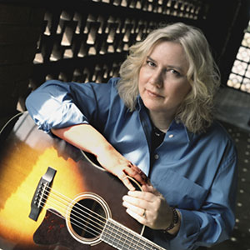
Harvard Public Library
Doors open at 7:00 PM
Show starts at 7:30 PM
Reserve seats:
978-456-4114

A fan favorite returning to HPL, Kate is a captivating artist. Her songs are thought- provoking, delightful, important and superbly, sweetly sung.
Michael Wilson
Seating is limited. Please call ahead to reserve seats. Free admission. Donations are appreciated. Further information: www.harvardpubliclibrary.org & www.katecampbell.com

