Harvard Friends of the Arts
Present
Mike & Ruthy of the Mammals
In Concert
Saturday, February 29 @ Harvard Public Library
Doors open at 7:00 PM
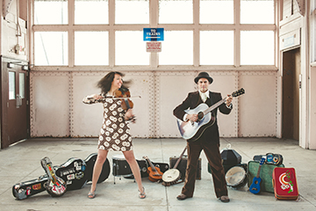
Show starts at 7:30 PM
Reserve seats: 978-456-4114
Mike Merenda and Ruth Ungar founded the folk-rock band The Mammals. They are Hudson Valley based songwriters who have made waves in the Americana world and beyond.
Seating is limited. Please call ahead to reserve seats.
Further information: www.harvardpubliclibrary.org &
www.mikeandruthy.com

