Harvard Friends of the Arts
Present
Molsky’s Mountain Drifters
In Concert
Saturday, December 7 @ Harvard Public Library
Doors open at 7:00 PM
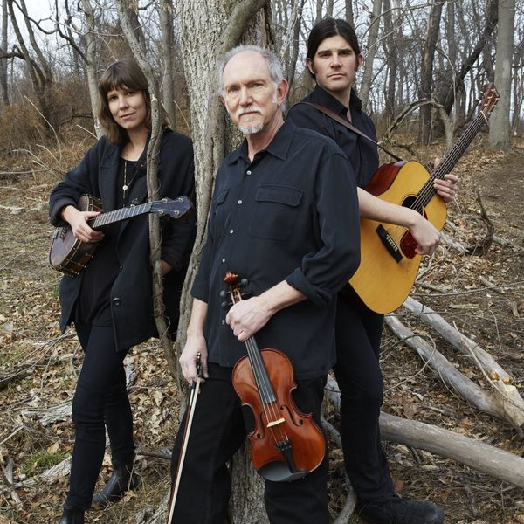
Show starts at 7:30 PM
Reserve seats: 978-456-4114
Bruce Molsky is one of those great players who 'gets it': has all the links to the past but is happy not to be chained to it." - Mark Knopfler Allison de Groot combines wide ranging virtuosity and passion for old-time music. Boston-based Stash Wyslouch is one of bluegrass’s great young genre-bending pioneers.
Kate Orne
Seating is limited. Please call ahead to reserve seats.
Free admission, donations are appreciated.
Further information: www.harvardpubliclibrary.org &
www.mountaindrifters.com

