Harvard Friends of the Arts
Present
Harvey Reid & Joyce Andersen
In Concert
Saturday, February 9 @ Harvard Public Library
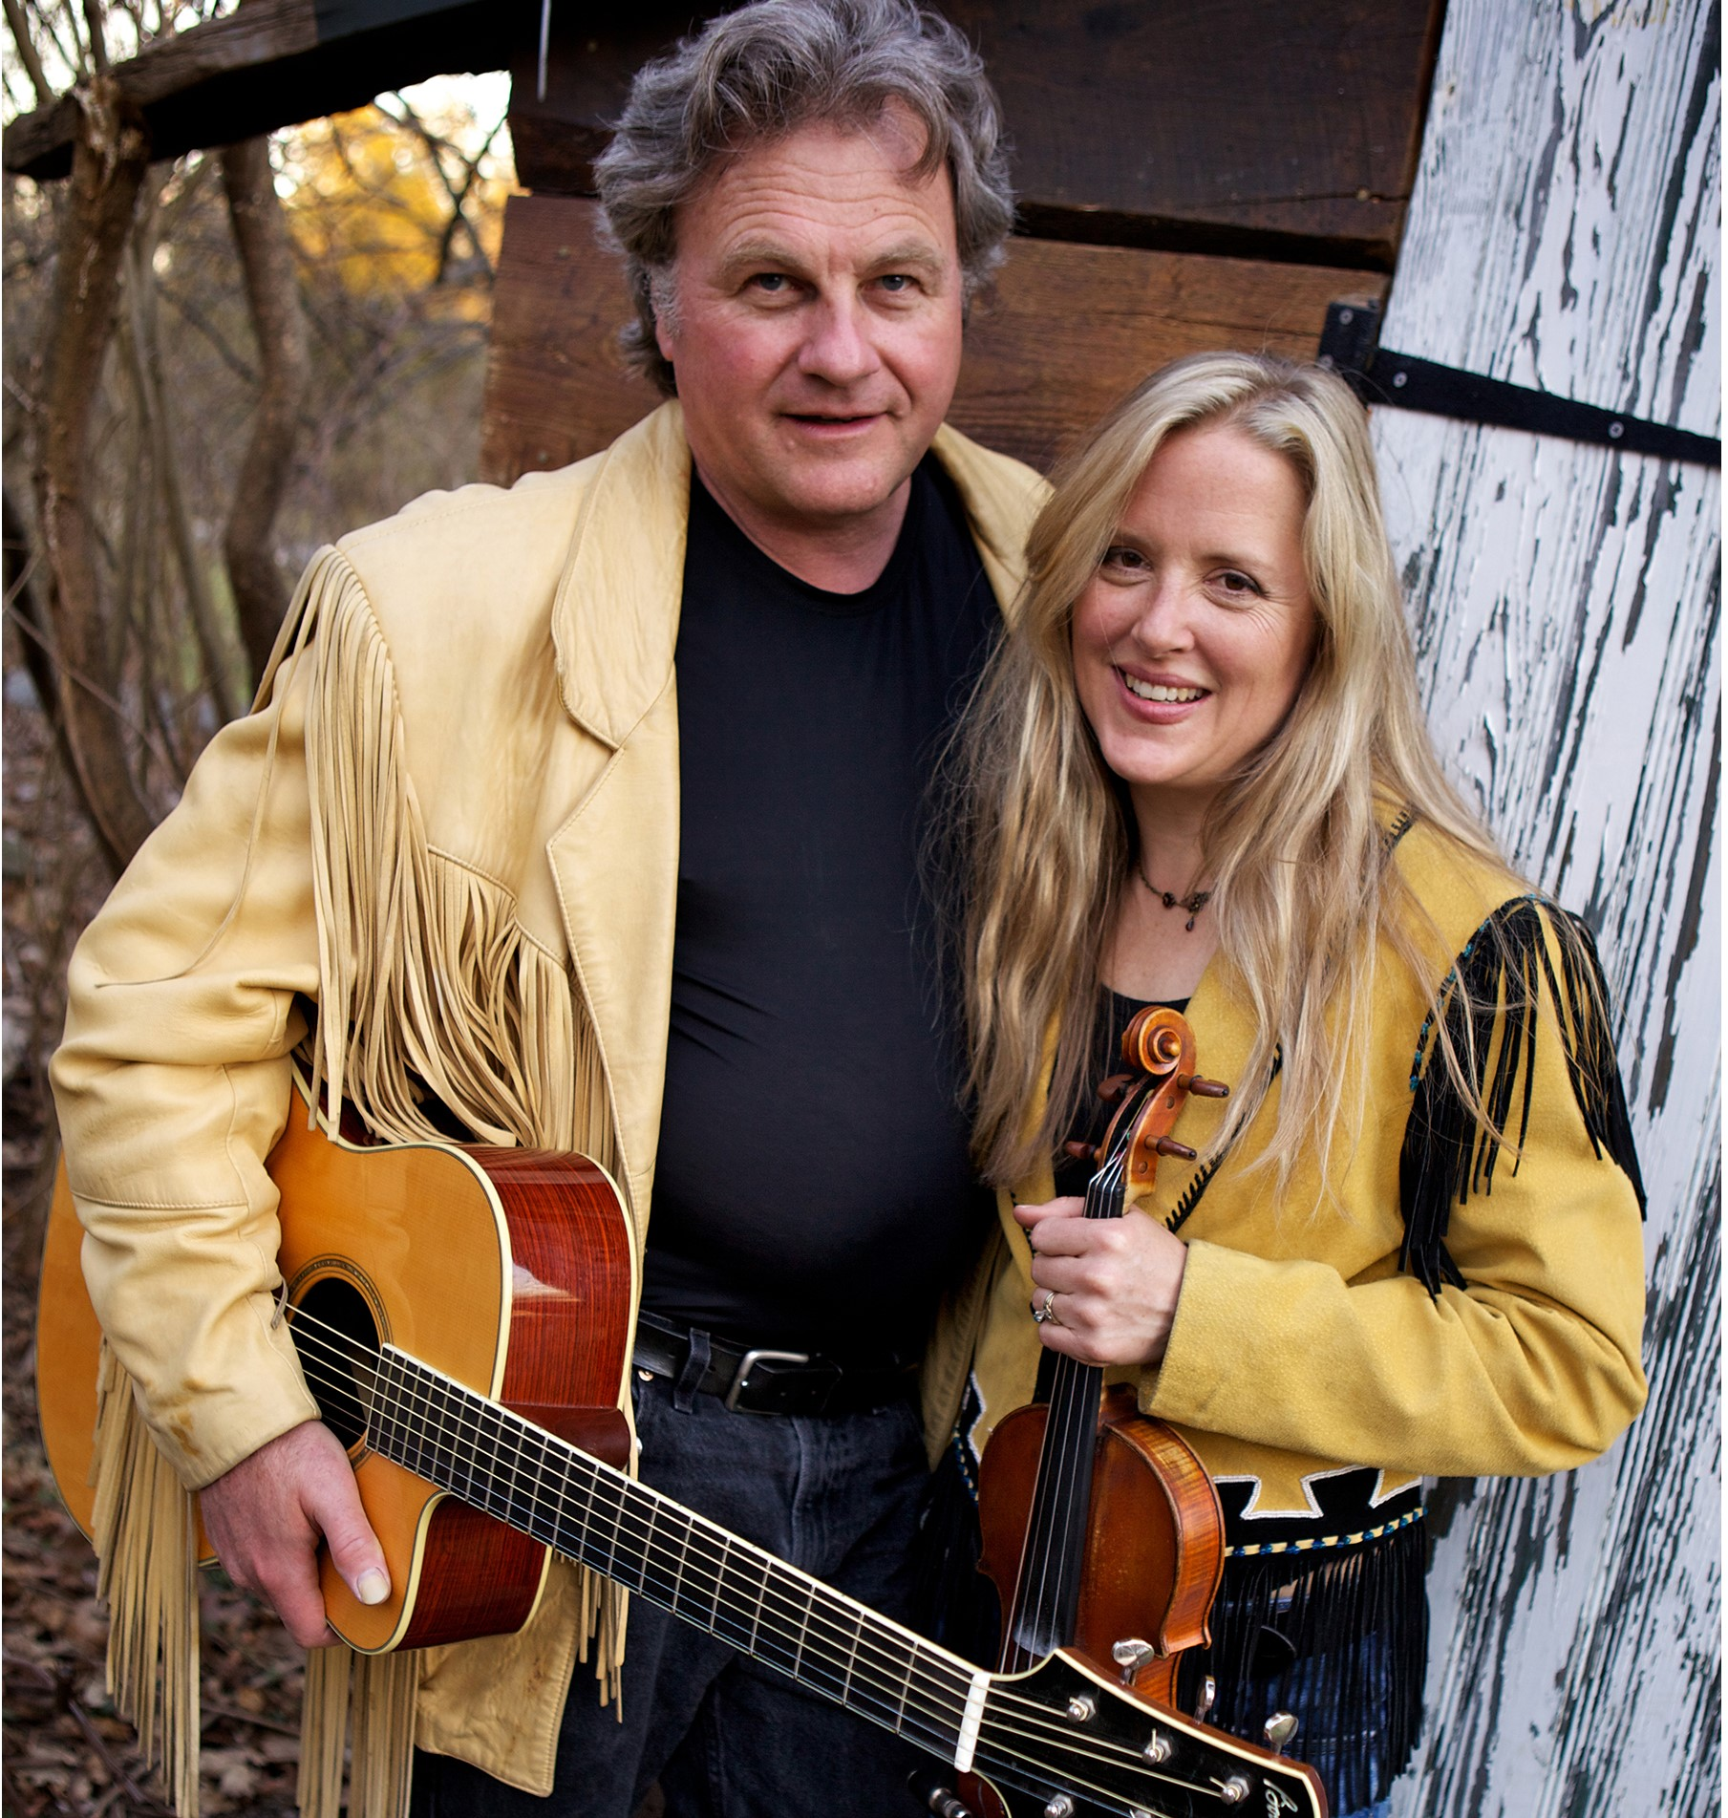
Doors open at 7:00 PM
Show starts at 7:30 PM
Reserve seats:
978-456-4114
Harvey Reid & Joyce Andersen form a rare
& versatile musical partnership, combining the
best of American virtuoso instrumental work with razor-sharp harmony singing and a captivating stage presence.
Photo by Amanda Kowalski

Seating is limited. Please call ahead to reserve seats.
Free admission, donations are appreciated.
Further information: www.harvardpubliclibrary.org &
www.woodpecker.com

