Harvard Friends of the Arts
Present
The Revenants
In Concert
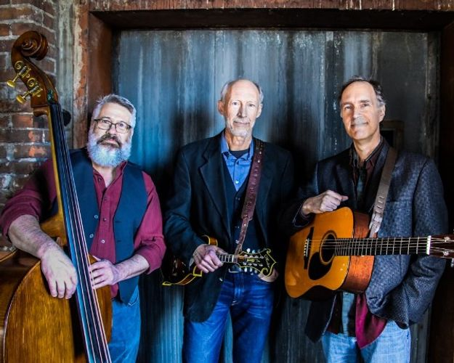
Saturday, October 13 @ Harvard Public Library
Doors open at 7:00 PM
Show starts at 7:30 PM
Reserve seats:
978-456-4114
Bluegrass Gospel Project alums Taylor Armerding, Andy Greene, and Kirk Lord have come together to present original, time-honored, and contemporary Americana music to venues throughout New England.
Seating is limited. Please call ahead to reserve seats.
Free admission, but donations are appreciated.
Further information: www.harvardpubliclibrary.org &
www.revenantsband.com

