The Friends of the Harvard Public Library welcomes donations of materials that can be sold during the Annual Book Sale to support our programs, including:
- Hardcover, paperback, and audiobooks.
- CDs and DVDs (in cases); record albums
- Jigsaw puzzles (bagged inside boxes)
Due to space limitations, we can only accept donations in the two weeks before the annual book sale.
All items must be in good or better condition. Items in poor / unsellable condition, or for which there is no market, create extra work for volunteers. Antique books in good condition are also welcome.
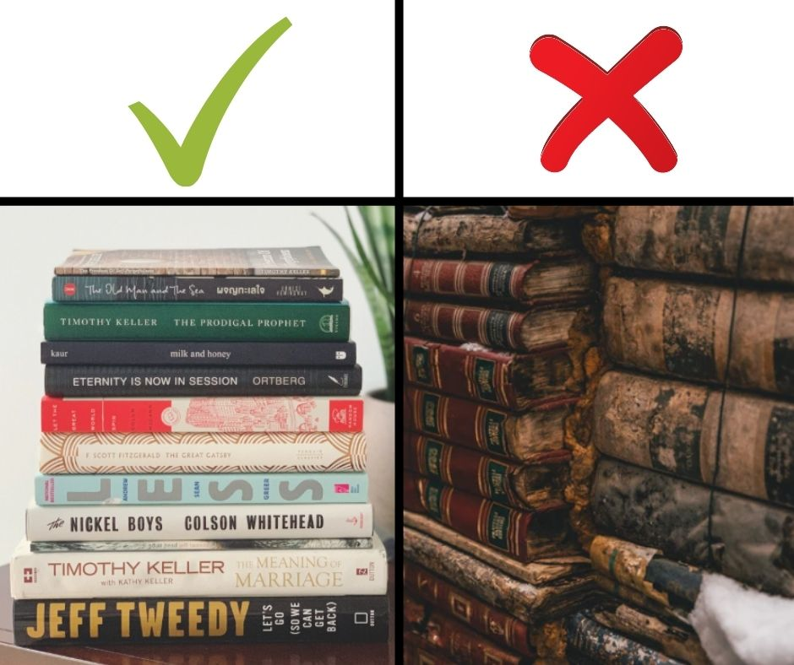 | Please do NOT bring:  - Books with mold or mildew, musty smell, water damage, stained or torn covers, broken spines, writing inside, or other physical damage;  - Condensed books, self-published books, encyclopedias, journals, or magazines;  - Cassette or VHS tapes;  - Medical, health, computer, technology, travel guides, or reference books more than 7 years old.

If you have a donation but are unable to come to normal donation times please email the Friends at HPLBooksale@gmail.com. A volunteer will contact you to make other arrangements.
Please do not bring donations to the Library on days other than our collection days. We have very limited storage space.
The book sale is the main fundraising event for the Friends of the Harvard Public Library. Proceeds allow the Harvard Public Library to fund Children’s Programs, Friends of the Arts performances, and Free Museum Passes among many other services.

To volunteer at the Annual book sale, please email HPLBooksale@gmail.com.
Thank you for your support of the Harvard Public Library!

